***e-Project: Star Brand***

STAR BRAND

|  |  |  |
| --- | --- | --- |
| **Supervisor.** | Sir Shakir Khan | |
| **Batch.** | 2305E1 | |
| **Group.** | 02 | |
| **Serial No.** | **Enrollment No.** | **Student Name** |
| 1. | Student1478236 | Atta Muhammad |
| 2. | Student1478241 | Hassan Ullah |
| 3. | Student1477700 | Aniqa Tauseef |
| 4. | _________ | ___________ |

*DEVELOPER GUIDE*

*(Star Brand) :-*

*NAV BAR HTML Code (Screen Shot):-*

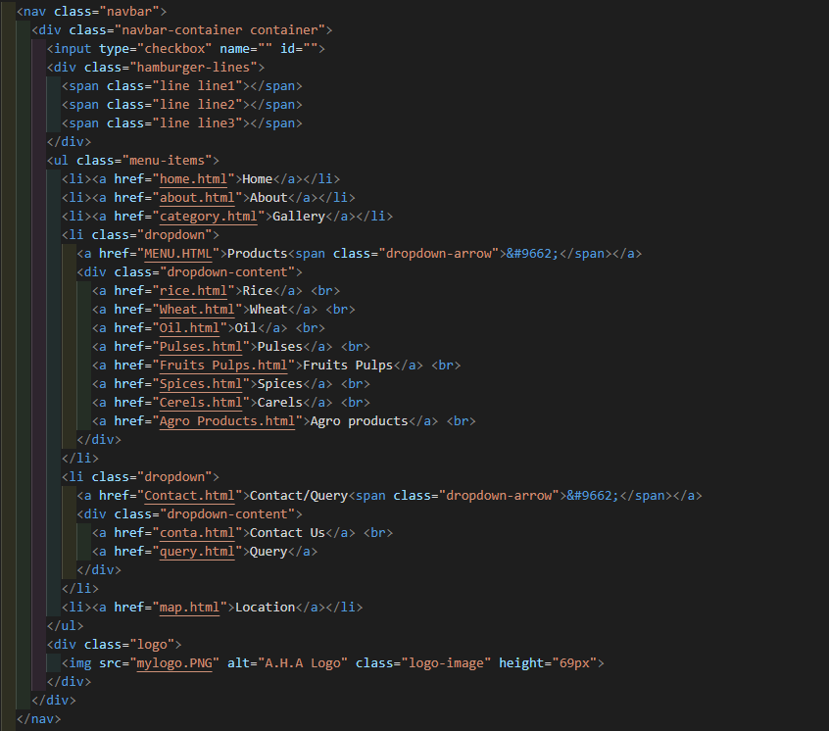

DESCRIPTION OF HTML :-

* <nav class="navbar">: This is the main container for the navigation bar.
* <div class="navbar-container container">: It's a container that holds the contents of the navbar. The container class is often used in web design frameworks like Bootstrap to center the content.
* <input type="checkbox" name="" id="">: This input element is used for creating a responsive menu button. When clicked, it toggles the display of the navigation menu on small screens (typically used for mobile devices).
* <div class="hamburger-lines">: This div element represents the "hamburger" menu icon often seen on mobile websites. It consists of three horizontal lines.
* <ul class="menu-items">: This unordered list (ul) contains the menu items (links) of the navigation bar.
* List Items (<li>) and Links (<a>):
* The list items contain links (<a>) to different pages of the website, such as Home, About, Gallery, Products (with a dropdown), Contact/Query (with a dropdown), and Location.
* The "Products" and "Contact/Query" items have dropdown menus represented by <div class="dropdown-content">. These dropdown menus contain links to subpages.
* <div class="logo">: This div element holds the website's logo, which is displayed on the right side of the navigation bar.
* <img src="mylogo.PNG" alt="A.H.A Logo" class="logo-image" height="69px">: This img element displays the website logo, with an alt attribute for alternative text and a defined height.

*NAV BAR CSS Code (Screen Shot):-*

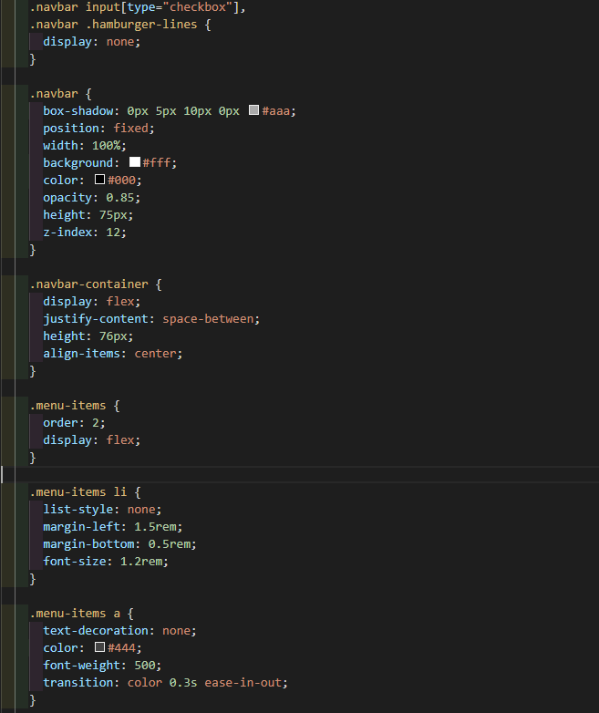

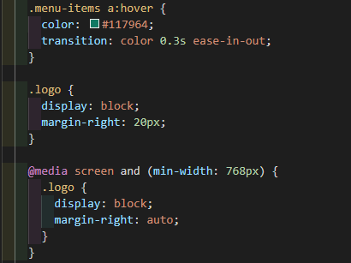

DESCRIPTION OF CSS :-

* Styling for the responsive navigation menu:
* The input[type="checkbox"] and .hamburger-lines elements are set to display: none, indicating that they are hidden.
* The checkbox and hamburger lines are typically used to create a mobile menu icon that appears when the screen size is small (e.g., for mobile devices).
* Styles for the main navbar container:
* It's given a fixed position at the top of the page.
* It has a white background, a shadow, and a specific height (75px).
* .navbar-container:
* Contains the navigation elements.
* Aligns elements within the navbar.
* .menu-items:
* Represents the list of menu items.
* For smaller screens, this list will typically be hidden, and the hamburger menu icon will be used to toggle its visibility.
* Menu item styles:
* List items (li) and links (a) within .menu-items are styled for legibility and interaction. Links change color when hovered over.
* .logo:
* Holds the website logo, with some margin for spacing.
* Responsive design:
* The design adapts for screens with a minimum width of 768px, making sure the logo is displayed correctly.

*NOTE:-*

You can consider adding this code and description to your developer guide, especially if you want to illustrate how to create a responsive navigation bar for a website. This example demonstrates a common structure for navigation bars and can be a useful reference for web developers.

*OUTPUT OF NAVIGATION BAR :-*

**

*FOOTER HTML Code (Screen Shot):-*

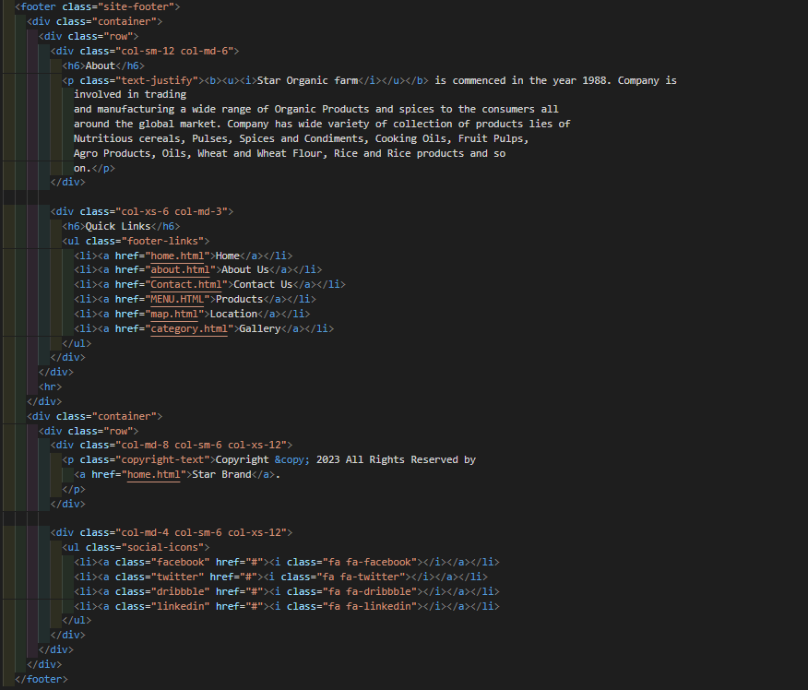

DESCRIPTION OF HTML :-

* <footer class="site-footer">: This element represents the footer section of a web page.
* Inside the footer, you have:
* Two main sections within the container:
* ***About Section:***
* <div class="col-sm-12 col-md-6">: This section takes up half of the available space in medium and larger screens.
* <h6>About</h6>: A heading "About."
* <p class="text-justify">: A paragraph of text describing "Star Organic Farm." The content describes the company's inception and its involvement in trading and manufacturing various organic products and spices.
* Quick Links Section:
* <div class="col-xs-6 col-md-3">: This section takes up one-third of the available space in small screens and one-quarter in medium and larger screens.
* <h6>Quick Links</h6>: A heading "Quick Links."
* <ul class="footer-links">: An unordered list for displaying quick links.
* Several list items (<li>) with anchor links (<a>) that lead to various pages on the website, such as Home, About Us, Contact Us, Products, Location, and Gallery.
* A horizontal rule (<hr>) that separates the two main sections.
* ***A Copyright Section:***
* <div class="col-md-8 col-sm-6 col-xs-12">: This section takes up two-thirds of the available space in medium and larger screens and the full width in small screens.
* <p class="copyright-text">: A copyright notice along with a link to the "Star Brand" website.
* A Social Icons Section:
* <div class="col-md-4 col-sm-6 col-xs-12">: This section takes up one-third of the available space in medium and larger screens and half the width in small screens.
* <ul class="social-icons">: An unordered list for displaying social media icons.
* List items (<li>) with anchor links (<a>) for various social media platforms (Facebook, Twitter, Dribbble, LinkedIn) and corresponding icons (font awesome icons).

*FOOTER CSS Code (Screen Shot):-*

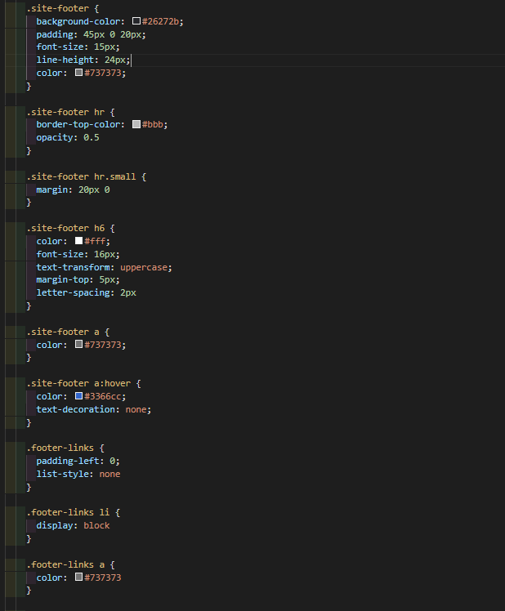

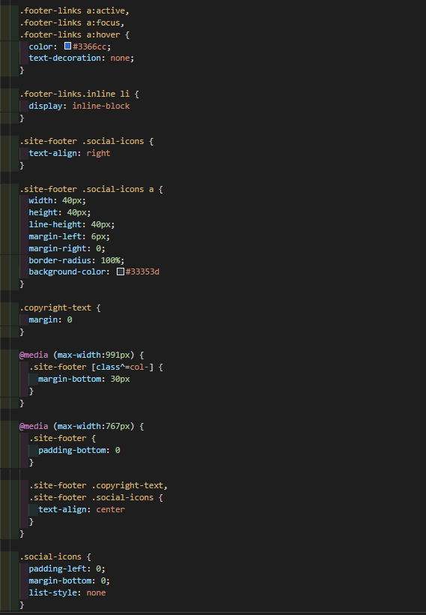

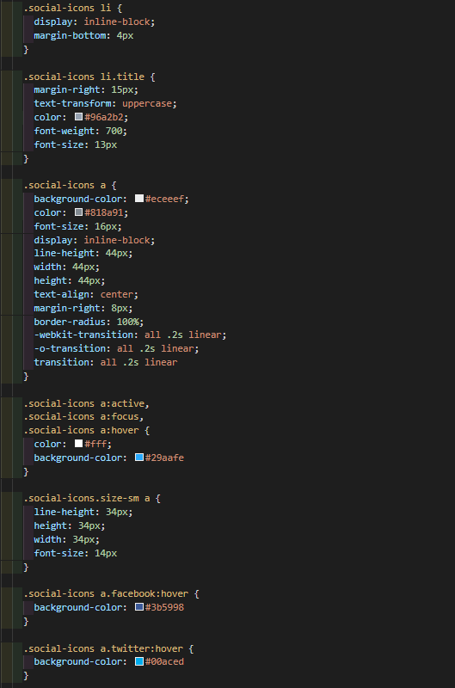

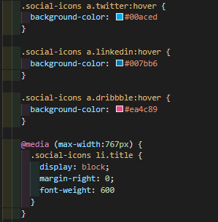

DESCRIPTION OF CSS :-

* .site-footer: This is the main container for the website footer. It sets the background color, padding, font size, and text color for the footer.
* .site-footer hr: This style is applied to horizontal lines within the footer. It sets the border color and opacity.
* .site-footer hr.small: This style is applied to a smaller horizontal line in the footer. It adds margin to the line.
* .site-footer h6: This style is applied to the heading element (<h6>) within the footer. It sets the font size, color, and text transformation.
* .site-footer a: These styles are applied to links within the footer. They set the default text color and specify the link color on hover.
* .footer-links: This style is applied to an unordered list (<ul>) used to display footer links. It removes list styling.
* .footer-links.inline li: This style is applied to list items within the inline footer links. It makes the list items display inline.
* .site-footer .social-icons: This style is applied to a list of social media icons. It aligns the icons to the right.
* Styles for social media icons:
* .social-icons a styles the social media icon links.
* .social-icons.size-sm a reduces the size of the social media icons for small screens.
* Hover styles are applied to the social media icons.
* Media queries:
* These styles are applied based on the screen size.
* For screens smaller than 991px and 767px, the footer layout and alignment are adjusted to be more responsive.

*NOTE:-*

You can consider adding this code and description to your developer guide, especially if you want to demonstrate how to create a responsive and styled footer for a website. It can serve as a good example of footer design. You might also want to add a note or comment explaining that the social media icons are represented by placeholder links and icons (like "fa fa-facebook") and that developers should replace them with actual social media links and icons according to their needs.

*OUTPUT OF FOOTER :-*

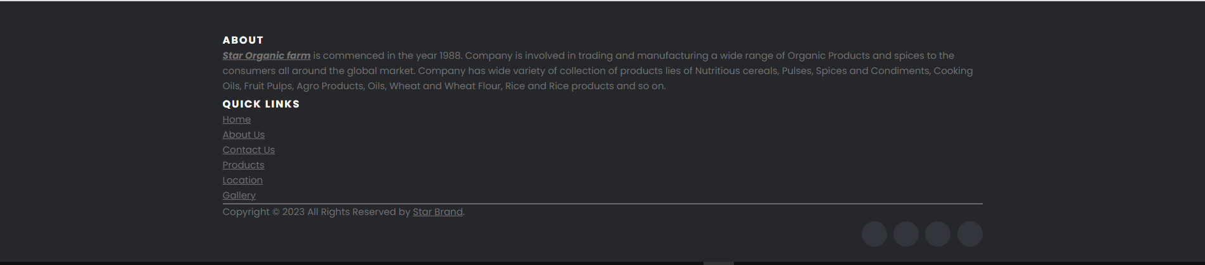

*MAP HTML Code (Screen Shot):-*

**

DESCRIPTION OF HTML :-

* <div id="map"></div>: This is a container for displaying a map. It has an ID of "map."
* <div class="map-zoom" onclick="zoomIn()">Zoom In</div>: This is a button labeled "Zoom In." It has a class of "map-zoom" and an onclick attribute that triggers a JavaScript function called "zoomIn" when clicked.

*MAP CSS Code (Screen Shot):-*

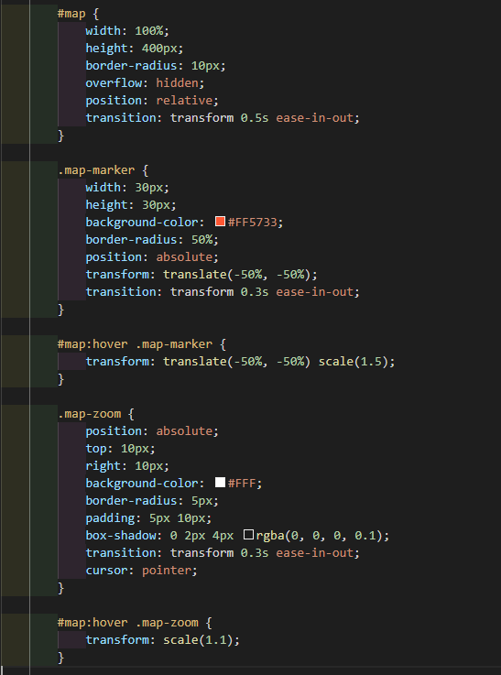

DESCRIPTION OF CSS :-

* #map: This is a CSS rule for the "map" element. It sets the width and height of the map container to 100% width and 400 pixels in height. It adds a border radius, makes it overflow hidden, and sets a transition for smooth zooming effects.
* .map-marker: This rule defines the style for a map marker. It sets the width, height, and background color of the marker. The marker is circular with a border radius, and it's initially positioned in the center of the map container. There's a transition for smooth scaling when hovered.
* #map:hover .map-marker: This selector targets the map marker when the map container is hovered over. It scales the marker by 1.5 times to make it appear larger when the user hovers over the map.
* .map-zoom: This rule styles the zoom control element. It sets its position, background color, border radius, padding, box shadow, and a transition for hover effects. It also changes the cursor to a pointer when hovered over.
* #map:hover .map-zoom: Similar to the map marker, this selector targets the zoom control element when the map container is hovered over. It scales the zoom control by 1.1 times to make it slightly larger when hovered.

*NOTE:-*

The provided code appears to be for adding a map with zoom functionality. It's a good example for your developer guide if you want to demonstrate how to integrate interactive maps into a web page using HTML and CSS. Additionally, it's helpful to add information about the JavaScript function zoomIn(), as it seems like an essential part of this feature. You can describe how this function works and provide any relevant JavaScript code for a complete implementation.

*OUTPUT OF MAP :-*

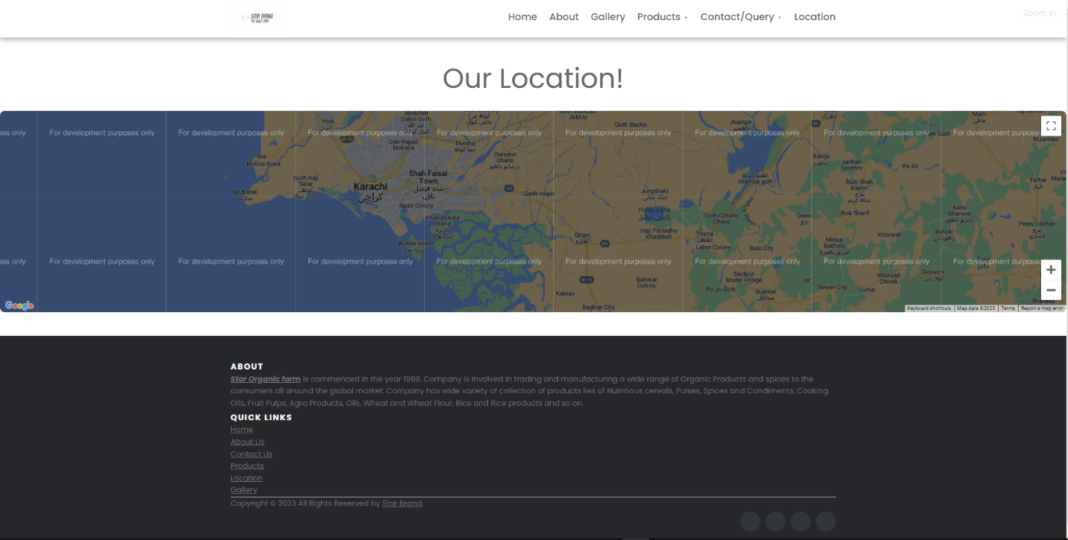

*REVIEWS HTML Code (Screen Shot):-*

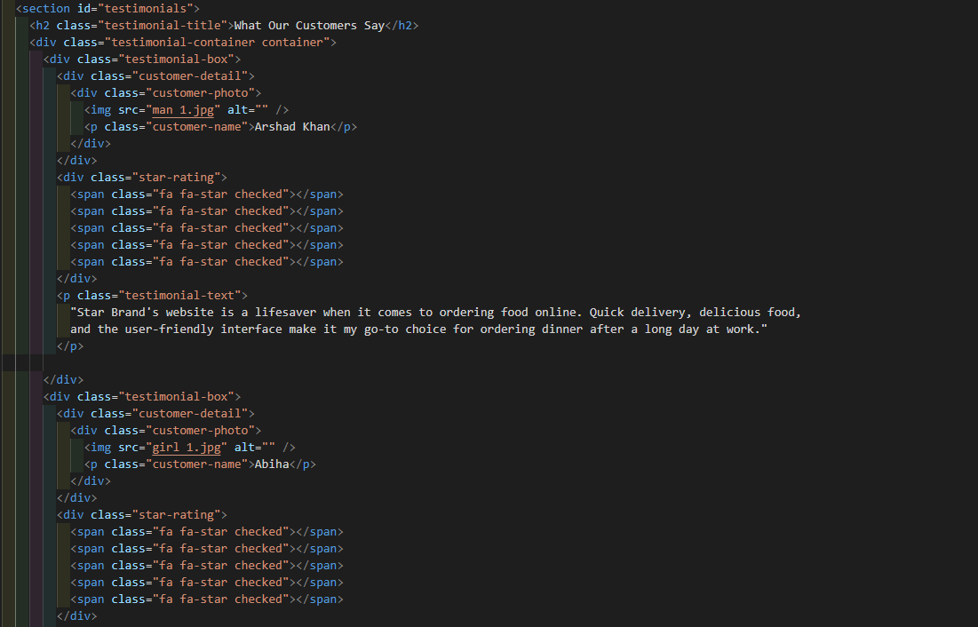

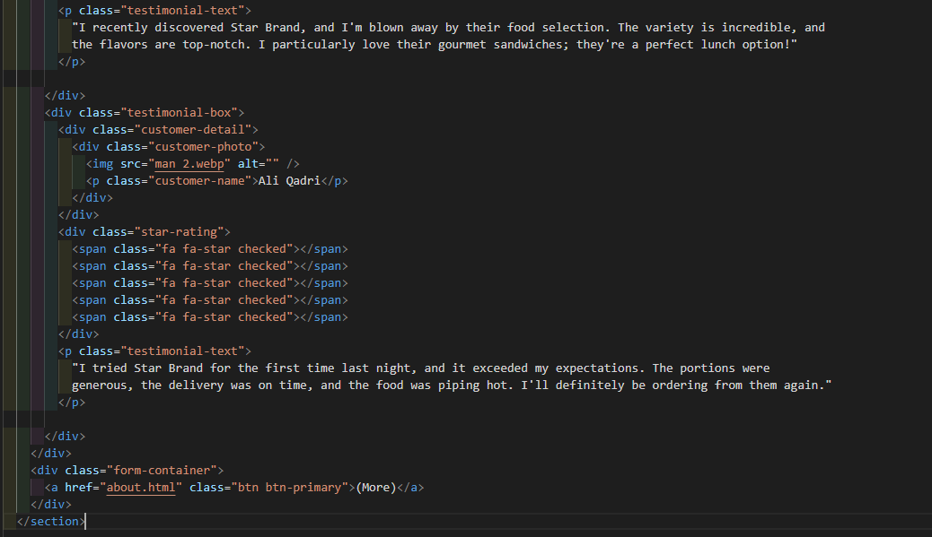

DESCRIPTION OF HTML :-

* <section id="testimonials">: This section is given the ID "testimonials" for styling and scripting purposes. It represents a section of the webpage dedicated to displaying customer testimonials.
* <h2 class="testimonial-title">What Our Customers Say</h2>: This is a heading that indicates the purpose of the section, which is to showcase customer testimonials.
* <div class="testimonial-container container">: This is a container for the testimonial elements, and it is centered within the webpage's content.
* Within the container, you have three "testimonial-box" elements, each representing a single customer testimonial. Each "testimonial-box" includes:
* "customer-detail": A container for the customer's information.
* "customer-photo": A container for the customer's photo, and an image of the customer.
* "p" element with "customer-name": The name of the customer.
* "star-rating": A container for displaying a star rating (with five checked stars). This indicates the customer's rating of the product or service.
* "p" element with "testimonial-text": The actual testimonial text where the customer shares their feedback and experience.
* After the testimonials, there is a "form-container" containing a button/link that allows users to access more information (e.g., a link to the "About" page).

*REVIEWS CSS Code (Screen Shot):-*

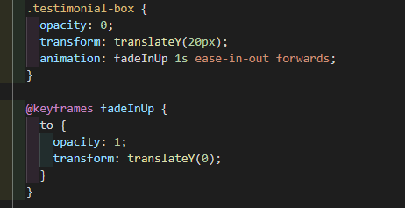

DESCRIPTION OF CSS :-

* The ".testimonial-box" elements have initial opacity set to 0, and they are translated upwards by 20px. This gives them a fade-in effect and a slight upward animation.
* An animation called "fadeInUp" is defined using keyframes. It gradually increases the opacity from 0 to 1 and moves the elements from a 20px higher position to their original position.

*NOTE:-*

This code can be added to your developer guide as an example of how to create a section for displaying customer testimonials with a fade-in animation. It's a common practice to add customer testimonials to a website to build trust and credibility, and this code can serve as a useful reference for developers looking to implement such a section on a webpage.

*OUTPUT OF REVIEWS :-*

**

*CONTACT HTML Code (Screen Shot):-*

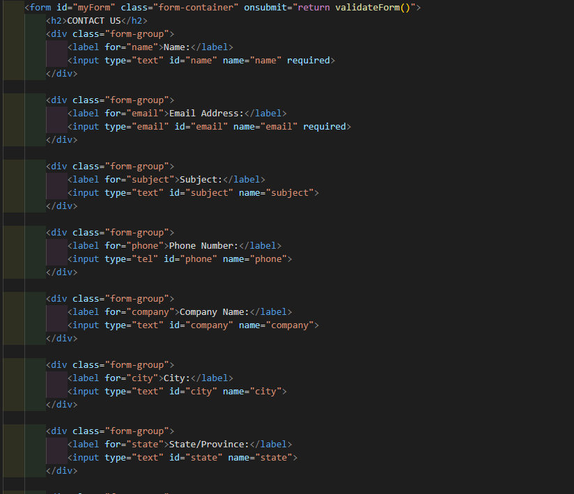

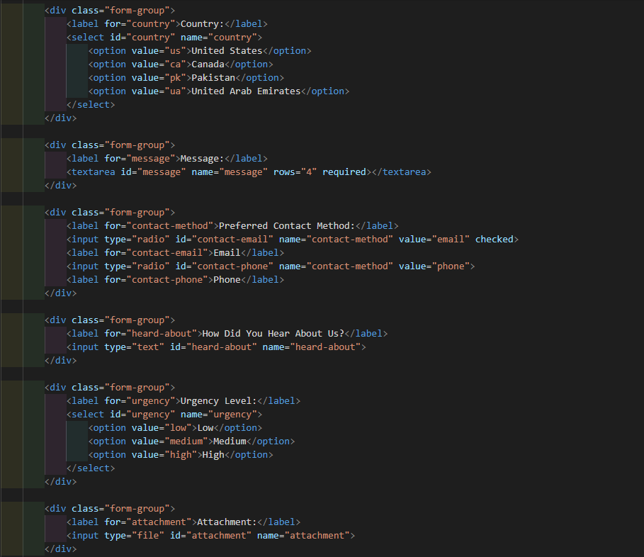

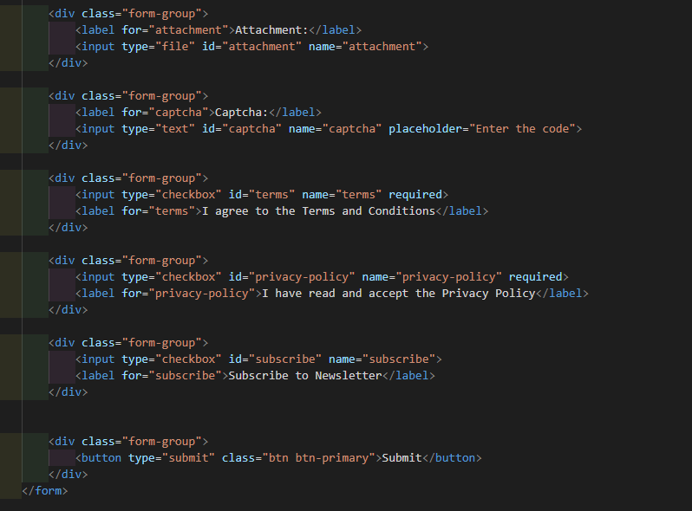

DESCRIPTION OF HTML :-

* The HTML <form> element with the ID "myForm" represents the main container for the contact form.
* Various form fields are included for users to enter their information, such as name, email, subject, phone number, company name, city, state, country, message, preferred contact method, how they heard about the website, urgency level, attachment, and checkboxes for terms and conditions, privacy policy, and newsletter subscription.
* Each form element is wrapped in a <div> with the class "form-group" to style and structure the form fields.
* A "Submit" button is included for users to submit the form.

*CONTACT CSS Code (Screen Shot):-*

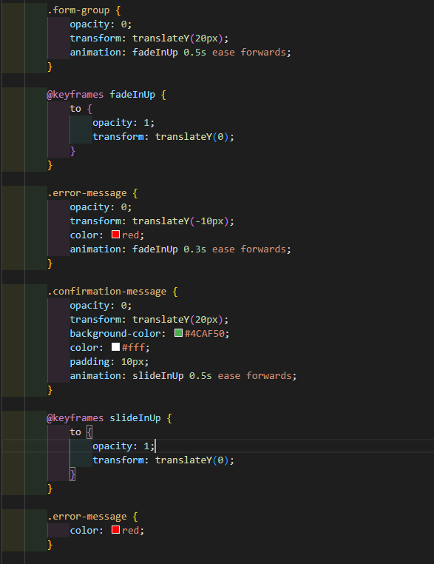

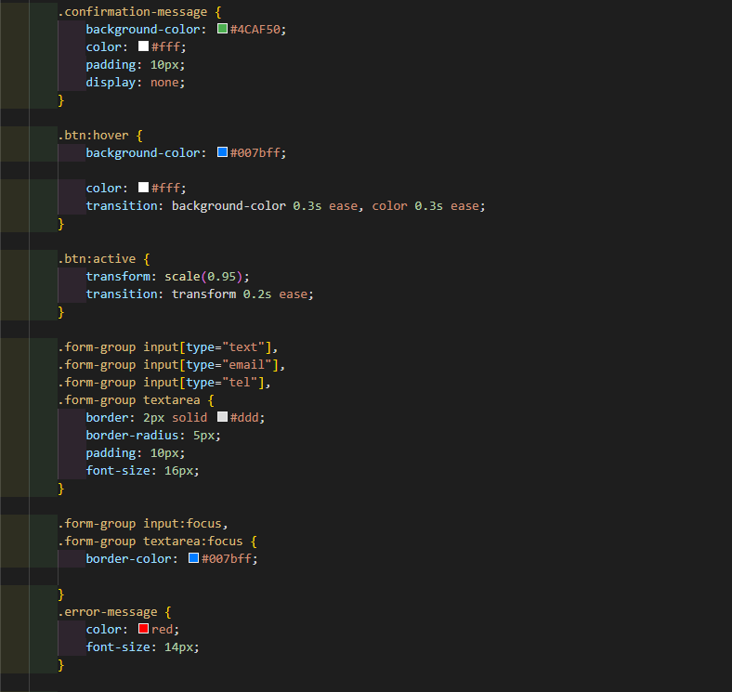

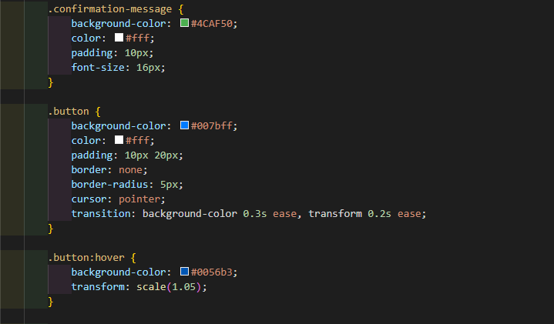

DESCRIPTION OF CSS :-

* The CSS code provides styling for the form elements. It includes various styling rules for text inputs, labels, buttons, checkboxes, and other form elements.
* There are also animations applied to the form elements, including a fade-in effect when the form elements first appear on the page.
* There are specific styles for error messages and a confirmation message that may be displayed after form submission.
* Additionally, there are styles for button hover and focus effects, such as changing background color and applying a slight scale transformation.

*NOTE:-*

You can add this code to your developer guide as an example of creating a contact form with various form elements and applying styles to make it visually appealing. It's important to note that server-side processing and validation for the form should be implemented to ensure security and proper functionality. This code provides the front-end structure and styling for the form.

*OUTPUT OF CONTACT US :-*

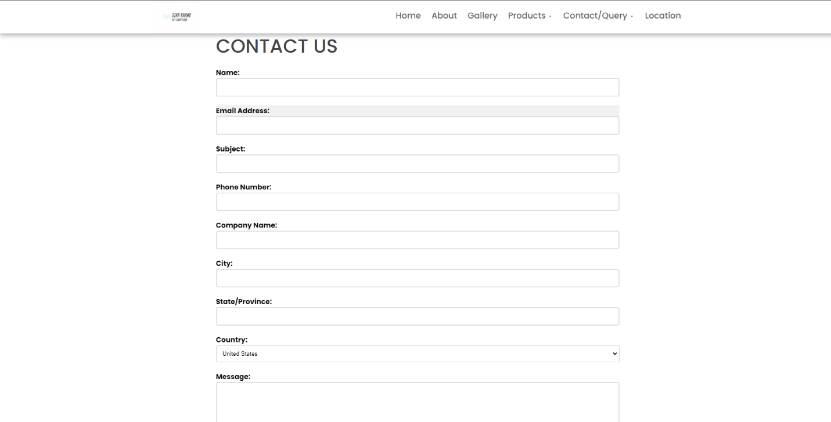

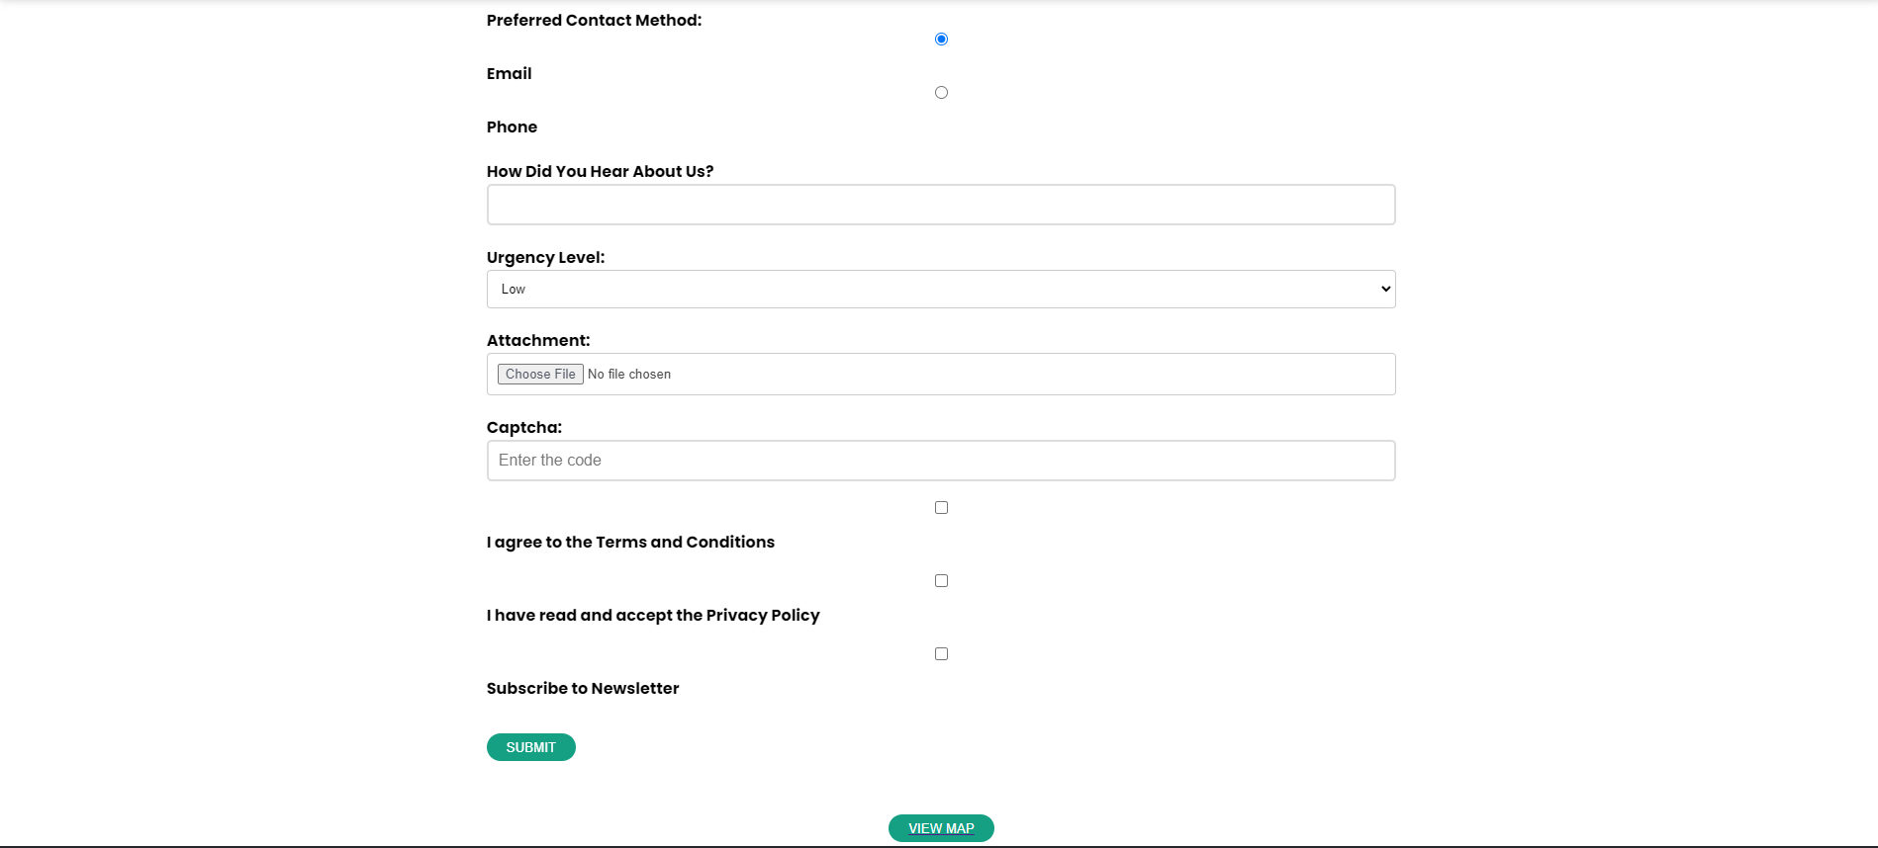

***Thank You For Reading The Documentation.***

***Please Follow The Instruction s Above !!***